**Online Shopping**

**Task 1.1: Benefits of Cloud Computing in Online Shopping:**

**1.Scalability:** Cloud offers a scalable and flexible solution to meet evolving business needs. Rather than purchasing and managing physical infrastructure to store and manage data and applications, the cloud enables businesses to quickly and easily scale their resources up or down as needed.

**2.Cost Savings:** A Cloud Hosted Desktop provides you with scalable computing power, while minimizing IT requirements and physical data storage, providing you with significant savings.

**3.Accessibility:** Keep users connected no matter where they work with anytime, anywhere, using any device. That means no more risk of files being stored on any computer.

**4.Customer Experience:** The data stored in the cloud empowers AI and ML to offer customers exactly the products and experiences they are looking for on your site.

**5.Security:** This helps your e-commerce organization have peace of mind knowing your sensitive data, including customers payment information, is secure.

**6. High Availability:** Cloud Services are designed for high availability, reducing the risk of downtime. If one server or data center experiences an issue, the workload can seamlessly switch to another location.

**7.Agility:** Being able to create advancements, generates and deploy digital content, react to seasonal changes.

**Task 1.2 Describe the Cap Ex and Op Ex and Examples**

**Cap Ex:** Cap Ex are funds used by a company to acquire, upgrade and maintain physical assets such as property, plants, buildings, technology or equipment.

Example: Physical assests, furniture and software.

**Op Ex:** The money a company or organization spends on an ongoing, day to day-to-day basis to run its business.

Example: Salaries, Maintenance cost, rent.

**Part 2: Understanding Public, Private, and Hybrid Clouds**

**Task 2.1:Difference**

**Private cloud**

Providing services to selected users and organizations.

Ex: organization

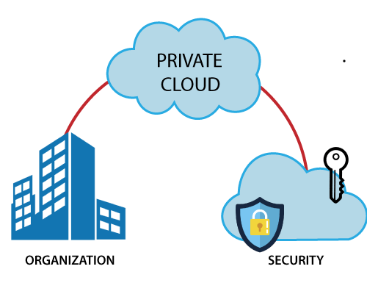

**Public cloud**

Services offered to public internet; anyone can signup

Ex: train ticket booking

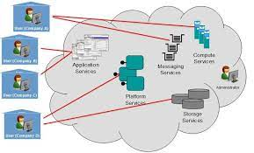

**Hybrid cloud**

Combination of public and private

Ex: bank

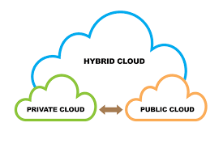

**Task 2.2: Real World Applications:**

**1.Public Cloud:**

**Real-World Application:** A startup company developing a new mobile app chooses to host their app on a public cloud platform. The company has limited resources and wants to minimize upfront costs. They also anticipate a variable and potentially high volume of users, making the scalability of public cloud resources ideal for their needs.

**2.Private Cloud:**

**Real-World Application:** A financial services firm with strict regulatory requirements decides to build a private cloud to host its financial data and applications. The firm needs to ensure data privacy, security, and compliance with regulations such as GDPR and HIPAA. A private cloud allows the firm to have full control over its infrastructure and data, meeting its security and compliance needs.

**3.Hybrid Cloud:**

**Real-World Application:** A retail company uses a hybrid cloud model to manage its e-commerce platform. The company uses the public cloud for hosting its website and handling peak shopping seasons when traffic is high. It uses a private cloud for sensitive data such as customer financial information, ensuring security and compliance with industry regulations. The hybrid cloud model allows the company to scale resources up or down based on demand while maintaining control over sensitive data.